|  |
| --- |
| C:\Users\Administrator\Desktop\logo.png |
| Business Process Management IS 362T |
|  |
|  |
| Information Systems Department **Amazon** |
| **First semester 1446** |

|  |
| --- |
|  |

|  |  |
| --- | --- |
| Student Name | ID |
| Raghad bin huzaim | 443007727 |
| Lama Alshaiban | 444009259 |
| Haneen Aljudaie | 444009218 |
| Rimas Alruqi | 443007748 |
| Rania Alqarni | 444009221 |

Table of contents

Table of Figures 1

Table of Work distribution 1

1.Business process discovery & Identification 1

1.1. Description of an organization 1

1.2. Process landscape model 1

1.3. Process stakeholders 1

1.4. Process objectives 1

1.5. Description of process 1

1.6. Scope the process 1

1.7. Business Process Management Notation (BPMN) 2

# Table of Figures

Figure 1 process landscape model 2

Figure 2 scope of process 2

# **1.Business process discovery & Identification**

# 1.1. Description of an organization

Amazon is one of the largest electronic platforms that offer many services and products and makes it easier for customers to search for and buy what they want, and also allows individuals to sell products through their platform. In addition, Amazon is characterized by selling all types of products and has a wide network of warehouses and uses advanced technologies such as artificial intelligence and Amazon serves its customers all the time, which improves the user experience

# 1.2. Process landscape model

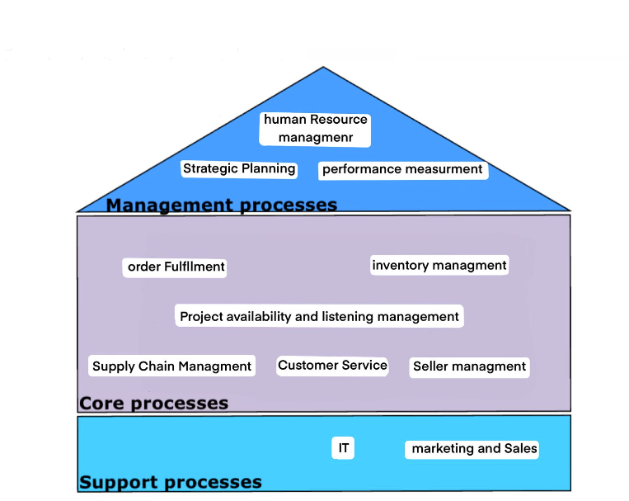

## Figure 1-1 process landscape model

# 1.3. Process stakeholders

1. Sellers / vendors.
2. Amazon seller support.
3. Amazon fulfilment centers
4. Buyers/ customers
5. Amazon payment and finance teams
6. Legal and compliance teams
7. Marketing and advertising teams
8. technical teams.

# 1.4. Process objectives

* Seller management objectives:
* Maximizing Sales and Revenue.
* Inventory Optimization.
* Listing Management.
* Customer Service Monitoring.
* Performance Analytics.
* Compliance and Policy Adherence

1.5. Description of process

Seller Management process

Product listing, continuous performance monitoring, and onboarding are all part of Amazon's seller management process. After registering on the site, sellers list their products, and they may have an option of using Amazon's Fulfillment by Amazon (FBA) service which is This service enables retailer to take advantage of Amazon's extensive fulfillment network. For Amazon to manage the logistics of order fulfillment, sellers keep their goods in its fulfillment centers. Or handling fulfillment themselves. Orders are completed and dispatched, and seller performance is monitored all the time based on feedback from customers, order flaws, and return rates. Amazon guarantees adherence to its regulations and regulatory requirements, helping sellers as required. Amazon Advertising and other promotional techniques are beneficial to sellers as well, and payments are made on a regular basis according to sales volume.

# 1.6. Scope the process

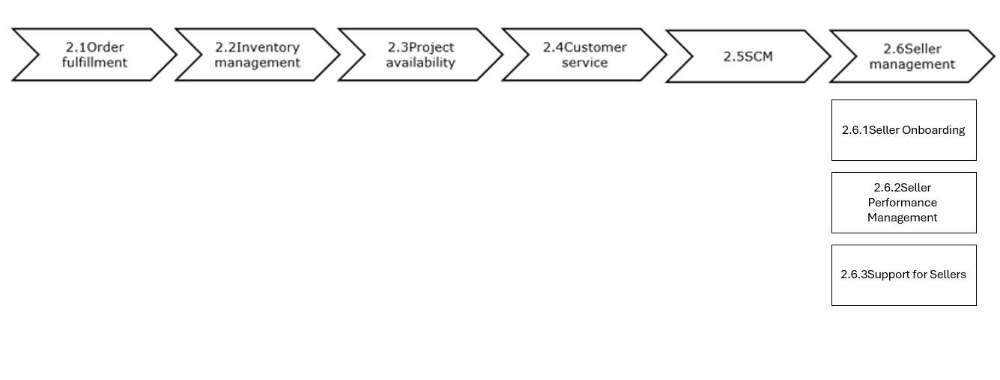

## Figure 1-2 scope of process

# 1.7. Business Process Management Notation (BPMN)

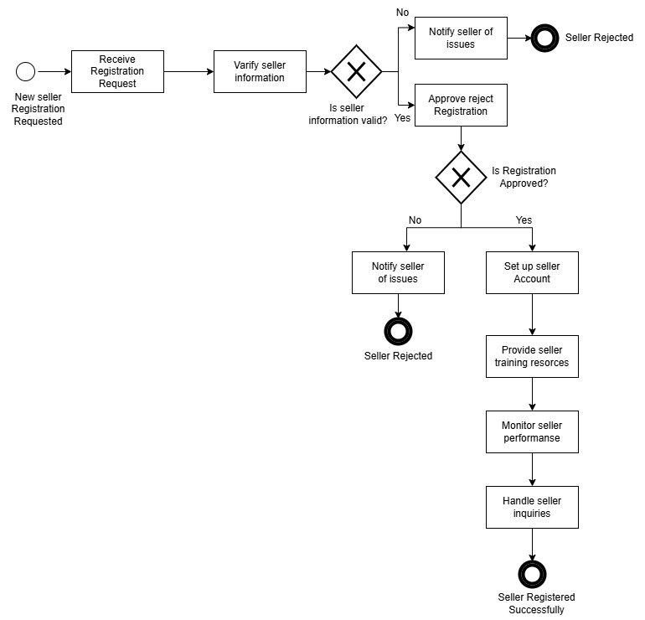

## Figure 1-3 Seller Management Process Notation

1.8. Ensure that the model is of good quality:

1-Semantic Quality: The flow logically sequences steps from receiving the registration request to its approval or rejection, with decision points to clarify options.  
2-Syntactic Quality: Proper symbols are used, with rectangles for tasks, diamonds for decisions, and arrows indicating the flow direction.  
3-Pragmatic Quality: The process is realistic and mirrors common steps for seller registration management, making it applicable to real-world scenarios.

1.9. Discovery Methods Used:

To gather information about the Amazon platform, we primarily utilized **evidence-based discovery**, analyzing documents such as policies and sales reports. Additionally, **observation** was employed to gain real insights into customer behaviors on the platform.

**2.Process Analysis Techniques**

2.1. Qualitative Analysis

* Value-add analysis

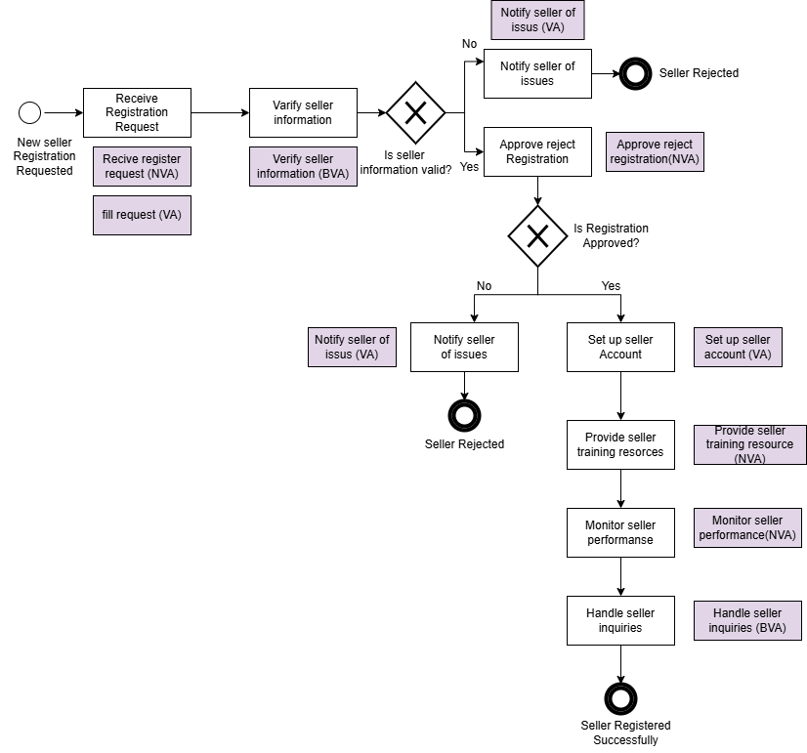

## Figure 2-1 Value-add analysis

|  |  |
| --- | --- |
| STEP | Classification |
| Receive register request | NVA |
| Fill request | VA |
| Verify seller information | BVA |
| Notify seller of issues | VA |
| Approve reject registration | NVA |
| Set up seller account | VA |
| Provide seller training resource | NVA |
| Monitor seller performance | NVA |
| Handle seller inquiries | BVA |

## Table 2-1 Value-add analysis

2.2 Qualitative Analysis

* Flow Analysis

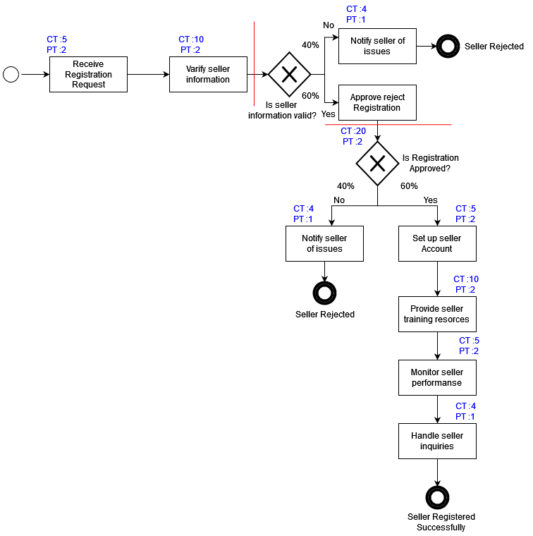

## Figure 2-2 flow analysis

|  |  |
| --- | --- |
| Activity | Cycle Time |
| Receive Registration Request | 5 |
| Verify seller information | 10 |
| Notify seller of issues | 4 |
| Approve reject Registration | 20 |
| Set up seller Account | 5 |
| Notify seller of issues | 4 |
| Provide seller training resources | 10 |
| Monitor seller performance | 5 |
| Handle seller inquiries | 4 |

## Table 2-2 Cycle time

|  |  |
| --- | --- |
| Activity | Process Time |
| Receive Registration Request | 2 |
| Verify seller information | 2 |
| Notify seller of issues | 1 |
| Approve reject Registration | 2 |
| Set up seller Account | 2 |
| Notify seller of issues | 1 |
| Provide seller training resources | 2 |
| Monitor seller performance | 2 |
| Handle seller inquiries | 1 |

## Table 2-3 Process time

* Cycle Time:

1. 5+10=15
2. [ (0.6 x 20) +(0.4 x 4)] =13.6
3. [ (0.6 x 24) +(0.4 x 4)] =16+20 x 0.6 =21.6

Total CT =15+13.6+21.6=50.2

* Process Time:

1. 2+2 =4
2. [(0.6 x 2) + (0.4 x 1)] =1.6
3. [(0.6 x 7) + (0.4 x 1)] =4.6 + 2 x 0.6 =5.8

Total PT = 4+1.6+5.8 =11.4

* Cycle Time Efficiency = PT /CT

=11.4/50.2 =0.227

=22.7%

2.2. Weakness and insights

2.2.1 Weakness

1. Receive registration request (NVA):  
   This step can be seen as bottlenecks if not automated, manual handling may delay the onboarding process.
2. Approve/Reject registration (NVA):

The decision-making process for approvals can be slow, particularly if it`s relies on manual checks or lacks clear criteria.

1. Monitor seller performance (NVA):

Ongoing monitoring can be resource-intensive and may not always yield actionable insights, especially if the matrix is not clearly defined.

1. Set up seller account (VA):

This can be a lengthy process if there are many manual inputs or if the system lacks automation, delaying seller ability to start selling

1. Provide seller training resources (NVA):

Training resources may not be readily accessible or engaging, leading to underutilization.

2.2.2 insights

1. Streamline registration process:

Implementing an automated system for receiving and processing registration request can significantly reduce lead time and improve the seller experience

1. Standardizing approval criteria:

Creating clear and standardized criteria for approving or rejecting registration can reduce ambiguity and speed up the process.

1. Notifying seller of Issus:

Prompt communication regarding any Issus improve seller experience and allow for quick resolution, fostering stronger relationship

1. Enhance training resources:

Making training materials more accessible and engaging can empower sellers to use available resources effectively.

1. Implementing performance feedback mechanisms:

Providing seller with actionable insight based on performance monitoring can help them improve their matrix

1. Improving communication for inquiries:

Streamlining the inquiry handling process through dedicated support channels can enhance overall seller satisfaction.

**3. Business process redesign**

Heuristic 1: Parallelism

* Automate seller validation and perform simultaneous basic document checks.
* Concurrently notify the seller and set up the account after approval.

Heuristic :2 Activity elimination

* Remove manual reception of requests and manual performance monitoring.
* Replace manual approval where feasible.

